Coal Lab Tasks 10
Task 1:
include irvine32.inc

.data
input byte "Enter a string: ",0
input2 byte 100 dup(?)
input3 byte "0123456789",0
msg1 byte "Password is strong",0
msg2 byte "Password must include at least 1 digit",0

.code
main proc
mov edx,offset input
call writeString
mov edx,offset input2
mov ecx,sizeof input2
call readString
call crlf
mov esi,offset input2
mov bl,0

L1:
lodsb
cmp al,0
je done
cmp al,'0'
jb L1
cmp al,'9'
ja L1
mov bl,1
jmp done

done:
cmp bl,1
je display1
mov edx,offset msg2
call writeString
jmp endif_

display1:
mov edx,offset msg1
call writeString

endif_:
exit
main endp
end main
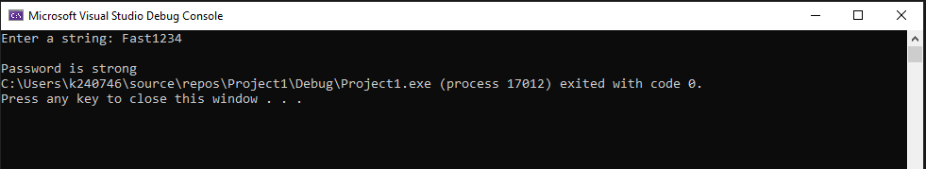
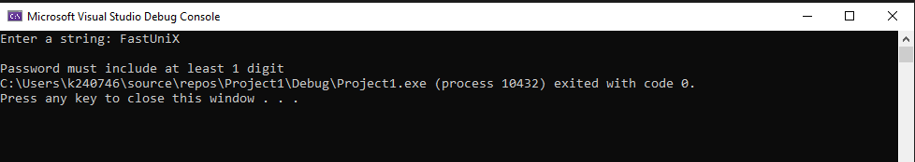
Task 2:
include irvine32.inc

.data
msg1 byte "Enter a string: ",0
msg2 byte "String without spaces: ",0
input byte 100 dup(?)
output byte 100 dup(?)

.code
main proc
mov edx,offset msg1
call writeString
mov edx,offset input
mov ecx,sizeof input
call readString
mov esi,offset input
mov edi,offset output

L1:
lodsb
cmp al,0
je done
cmp al,' '
je L1
stosb
jmp L1

done:
mov edx, offset msg2
call writeString
mov edx, offset output
call writeString

exit
main endp
end main
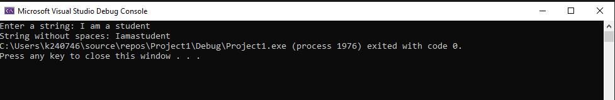
Task 3:
include irvine32.inc

.data
msg1 byte "Enter a string: ",0
msg2 byte "Number of words: ",0
input byte 100 dup(?)
count dword ?

.code
main proc
mov edx,offset msg1
call writeString
mov edx,offset input
mov ecx,sizeof input
call readString

mov esi,offset input
mov count,0
mov bl,0

L1:
lodsb
cmp al,0
je done

cmp al,' '
je found
cmp bl,1
je L1
inc count
mov bl,1
jmp L1

found:
mov bl,0
jmp L1

done:
mov eax,count
mov edx,offset msg2
call writeString
call writeDec
exit
main endp
end main
